Property 1 — Horizon Crest Tower
--------------------------------------------------------------------------------

Title: Horizon Crest Tower — Premium High-Rise Apartment
Type: Apartment (High-Rise)
Status: For Rent
City: Karachi
Location: Clifton Block 5, Karachi
Monthly Rent: PKR 135,000 / Month
Security Deposit: 3 Months Advance
Size: 1,450 Sq. Ft.
Floor: 12th Floor (out of 18 floors)
Bedrooms: 3
Bathrooms: 2
Agent: Zain Mirza

Short Description:
A well-positioned high-rise rental apartment in the heart of Clifton offering panoramic city views, modern finishes, and 24/7 security in one of Karachi's most sought-after residential corridors.

Full Description:
Horizon Crest Tower stands tall in Clifton Block 5, one of Karachi's most prestigious and centrally located neighbourhoods. This 1,450 Sq. Ft. apartment on the 12th floor offers sweeping views of the surrounding cityscape framed against the Karachi hills. The building's contemporary architecture — defined by its curved balconies and white-and-terracotta facade — reflects a mid-premium aesthetic that blends well into the upscale Clifton skyline.

The apartment features a spacious open-plan living and dining area with floor-to-ceiling windows that flood the interior with natural light. The kitchen is fitted with modular cabinets and granite countertops, while all three bedrooms offer built-in wardrobes and attached or shared bathrooms. Italian marble flooring runs throughout the main areas. Located minutes from Dolmen Mall Clifton, Karachi Cantonment, and major commercial avenues, this is an ideal choice for urban professionals and families looking to rent a prime Karachi address.

Features & Amenities:
- 3 Bedrooms, 2 Bathrooms
- 12th Floor with City View
- Italian Marble Flooring
- Modular Kitchen with Granite Countertops
- 24/7 Security & CCTV Surveillance
- Elevator Access (2 Lifts)
- Dedicated Parking (1 Covered Space)
- Backup Generator for Common Areas
- Rooftop Community Terrace
- Close Proximity to Clifton Commercial Areas

GPS Coordinates: 24.8122, 67.0322
Photo Reference: Property 1(Rent).jpg
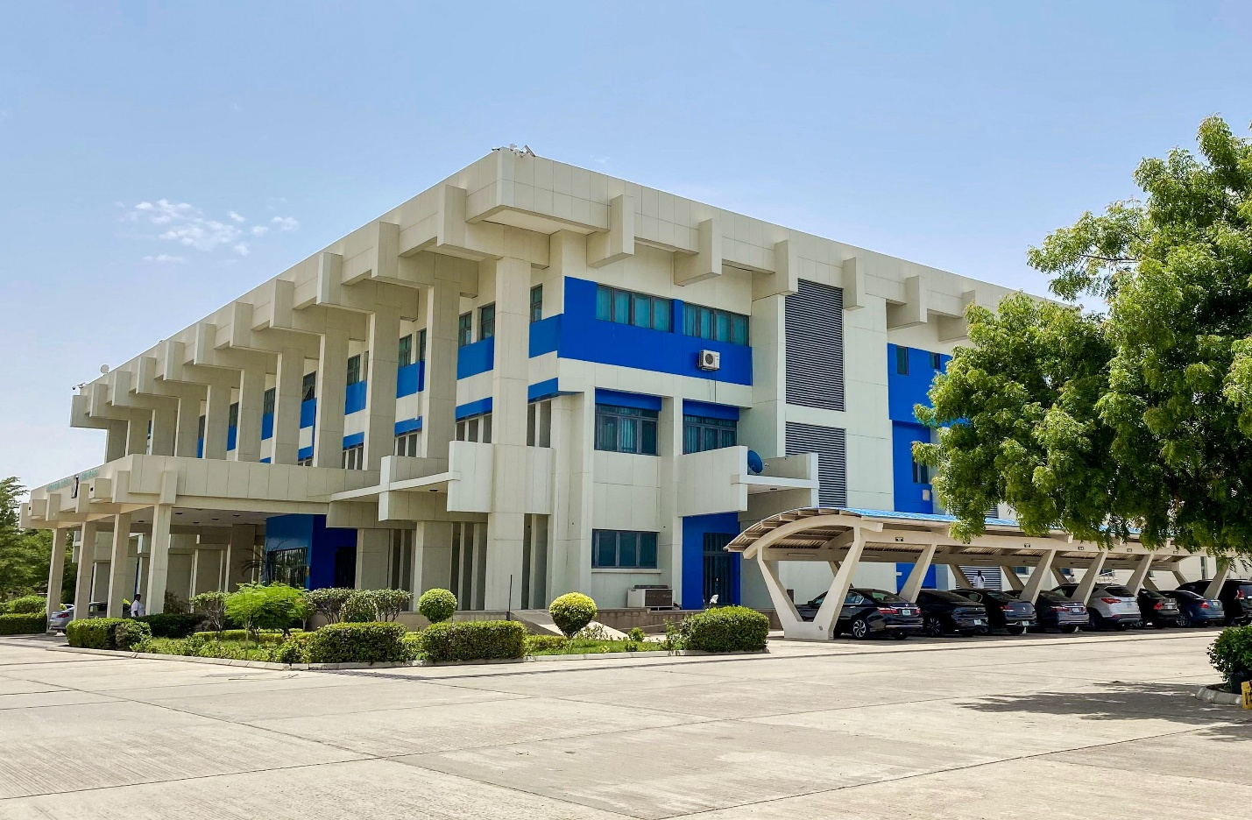

--------------------------------------------------------------------------------
Property 2 — Al-Faisal Classic Residency
--------------------------------------------------------------------------------

Title: Al-Faisal Classic Residency — Vintage Mid-Rise Apartment
Type: Apartment (Mid-Rise)
Status: For Rent
City: Karachi
Location: PECHS Block 2, Karachi
Monthly Rent: PKR 65,000 / Month
Security Deposit: 2 Months Advance
Size: 900 Sq. Ft.
Floor: 3rd Floor (out of 6 floors)
Bedrooms: 2
Bathrooms: 2
Agent: Zain Mirza

Short Description:
A solidly built mid-rise rental apartment in PECHS with a distinctive arched facade and timeless architecture — an excellent, central home option in one of Karachi's most established residential areas.

Full Description:
Al-Faisal Classic Residency is a well-established mid-rise apartment block located in PECHS Block 2, a mature and densely connected neighbourhood in Karachi. The building is instantly recognisable by its striking cream-coloured facade featuring repeating oval arches — a design characteristic of late 1980s and 1990s Karachi construction that has made it a local landmark.

The 900 Sq. Ft. unit on the 3rd floor consists of 2 bedrooms, 2 bathrooms, a lounge, dining area, and a functional kitchen. The apartment receives good cross-ventilation through its arched window recesses. It provides a reliable, structurally solid layout perfect for small families or working individuals looking for long-term tenancy. PECHS is one of Karachi's busiest commercial-residential corridors, putting you close to Shahrah-e-Faisal, Tariq Road, and major hospitals and schools.

Features & Amenities:
- 2 Bedrooms, 2 Bathrooms
- Iconic Arched Facade Architecture
- Cross-Ventilated Units
- Ground-Level Parking Available
- Close to PECHS Commercial Markets
- Walking Distance to Main Road Transport
- Reliable Water Supply (Overhead Tank + Pump)
- Separate Servant Quarter
- 24/7 Watchman on Duty

GPS Coordinates: 24.8699, 67.0626
Photo Reference: Property 2(Rent).jpg

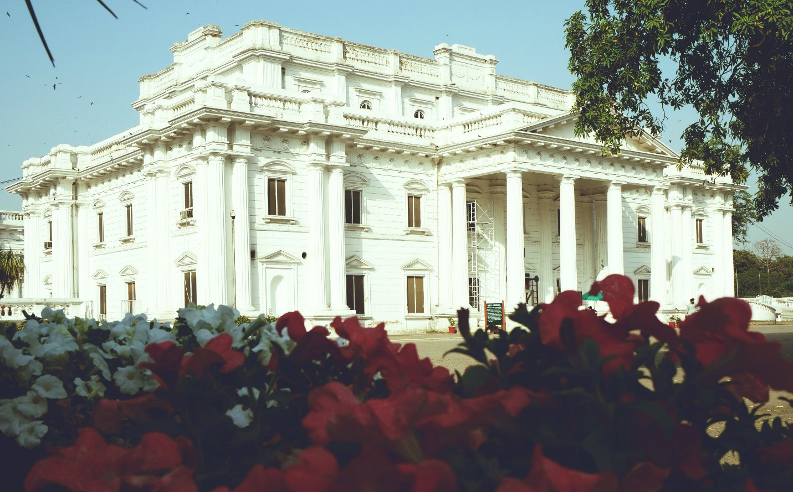

--------------------------------------------------------------------------------
Property 3 — Green Canopy Cottage
--------------------------------------------------------------------------------

Title: Green Canopy Cottage — Rustic Single-Storey House
Type: House (Cottage/Independent)
Status: For Rent
City: Islamabad
Location: Sector F-6 Margalla Foothills, Islamabad
Monthly Rent: PKR 110,000 / Month
Security Deposit: 2 Months Advance
Size: 5 Marla (1,125 Sq. Ft.)
Floors: Single Storey
Bedrooms: 2
Bathrooms: 1
Agent: Zain Mirza

Short Description:
A rare, character-rich rental cottage nestled in Islamabad's Margalla foothills zone, featuring a half-timber facade and green tin roof — perfect for tenants seeking a peaceful retreat away from the city's hustle.

Full Description:
Tucked beneath a canopy of mature chinar and eucalyptus trees in the Margalla foothills fringe of Islamabad, Green Canopy Cottage is a distinctive single-storey property that stands apart from typical urban housing. Its half-timber facade — white plaster panels divided by dark wooden beams in a cross-pattern — gives it a European countryside aesthetic that is remarkably rare in the capital.

The property sits on 5 Marla of land with a large open yard blanketed in autumn foliage, offering complete privacy and a deeply serene environment. The interior comprises 2 bedrooms, 1 bathroom, a compact lounge, and a basic kitchen. This property is ideally suited to nature-lovers, artists, or expatriates looking for a quiet, green lifestyle in a premium Islamabad address. The location offers easy access to Margalla Hills hiking trails, Daman-e-Koh, and the Islamabad Expressway, with utility connections like water, electricity, and sui gas already actively serving the residence.

Features & Amenities:
- Distinctive Half-Timber Architectural Style
- 5 Marla Open Plot with Mature Trees
- Peaceful Foothills Location
- Walking Distance to Margalla Trails
- Separate Outdoor Yard / Garden Area
- Active Sui Gas, Water & Electricity Connections
- Quiet Street with Low Traffic
- Close to Islamabad Expressway

GPS Coordinates: 33.7516, 73.0654
Photo Reference: property 3(rent).jpg

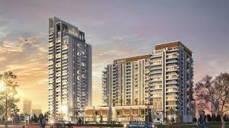

--------------------------------------------------------------------------------
Property 4 — Noor-ul-Hayat Grand Plaza
--------------------------------------------------------------------------------

Title: Noor-ul-Hayat Grand Plaza — Luxury Islamic-Architecture Building
Type: Commercial / Luxury Residential (Mixed Use)
Status: For Rent
City: Islamabad
Location: Blue Area, G-7, Islamabad
Monthly Rent: PKR 1,400,000 / Month
Security Deposit: 6 Months Advance
Size: 8,000 Sq. Ft. (Full Floor / Full Building Options Available)
Floors: 5 Storeys
Bedrooms: N/A (Commercial / Mixed Use)
Bathrooms: 6
Agent: Zain Mirza

Short Description:
A commanding premium-grade commercial property for lease in Islamabad's Blue Area, featuring elegant Islamic-inspired architecture, solar panels, and grand arched windows — ideal for corporate headquarters, embassies, or high-end hospitality use.

Full Description:
Noor-ul-Hayat Grand Plaza is one of Islamabad's most architecturally distinguished commercial lease opportunities — a 5-storey building finished in pristine white marble cladding with bold teal-green Islamic lattice work running across its facade. Pointed arches frame the ground-floor entrance, while the upper floors are defined by ornate arched windows and geometric tile bands that give the building a timeless, classical feel.

The rooftop is equipped with a sizeable solar panel array, reflecting a commitment to energy efficiency that drastically reduces operational overhead for corporate tenants. The structure is built to premium specifications with high-grade exterior cladding, wide internal corridors, and generous floor plates perfectly suited for open-plan office configurations or boutique hospitality layouts. Located in the heart of Blue Area — Islamabad's central business district — the property enjoys direct access to the city's main commercial artery and is surrounded by government offices, embassies, and multinational corporate headquarters.

Features & Amenities:
- Premium Islamic-Inspired Architecture
- White Marble Exterior Cladding
- Teal-Green Islamic Lattice & Arched Windows
- Active Solar Panel Array on Rooftop
- 5 Storeys with Large Floor Plates
- High Ceilings (12 ft minimum)
- Central Location in Blue Area Business District
- Perfect for Corporate HQ, Embassy, or Luxury Hospitality Use
- Underground Parking Available
- 24/7 Security & Access Control

GPS Coordinates: 33.7215, 73.0886
Photo Reference: Property 4(rent).jpg

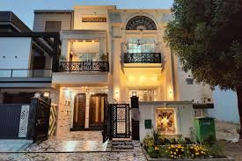

--------------------------------------------------------------------------------
Property 5 — Bosphorus View Mansion
--------------------------------------------------------------------------------

Title: Bosphorus View Mansion — Luxury 3-Storey Villa with Rooftop Terrace
Type: House / Villa (Luxury)
Status: For Rent
City: Lahore
Location: DHA Phase 6, Lahore
Monthly Rent: PKR 450,000 / Month
Security Deposit: 3 Months Advance
Size: 2 Kanal (4,500 Sq. Ft. Built-Up)
Floors: 3 Storeys + Rooftop Terrace
Bedrooms: 6
Bathrooms: 5
Agent: Zain Mirza

Short Description:
An exceptional 2-Kanal luxury rental villa in DHA Phase 6 Lahore featuring a rooftop entertaining terrace, arched verandahs, and lush landscaped surroundings — an elite residential lease offering.

Full Description:
Bosphorus View Mansion is a stunning 2-Kanal premium villa located in the tree-lined avenues of DHA Phase 6, Lahore — one of the most desirable residential choices in the country. The property rises beautifully across three well-proportioned floors, each featuring wide arched verandahs and floor-to-ceiling windows that draw in the golden Lahore sunset. A fenced rooftop terrace with metal railing completes the structure, offering panoramic views of the neighbourhood's lush green canopy.

The interior is finished to a premium standard with Italian marble on the ground floor, hardwood timber on the upper floors, designer lighting, and custom carpentry throughout. The ground floor features a formal drawing room, dining space for 12, a fully equipped kitchen, and a guest bedroom with an attached bath. Upper floors contain 5 bedrooms including an expansive master suite with a walk-in wardrobe and an en-suite bathroom with imported fixtures. Outside, mature trees and manicured hedgerows create a natural screen from the street, while a 2-car porch and service entrance are provided at the rear.

Features & Amenities:
- 2 Kanal Plot with 4,500 Sq. Ft. Built-Up Area
- 6 Bedrooms, 5 Bathrooms
- Rooftop Entertaining Terrace with Metal Railing
- Arched Verandahs on All Floors
- Italian Marble Ground Floor & Hardwood Upper Floors
- Fully Equipped Modular Kitchen
- Formal Drawing Room & Dining Area
- 2-Car Porch + Rear Service Entrance
- Landscaped Garden & Secure Boundary Wall

GPS Coordinates: 31.4732, 74.3987
Photo Reference: Property 5(Rent).jpg

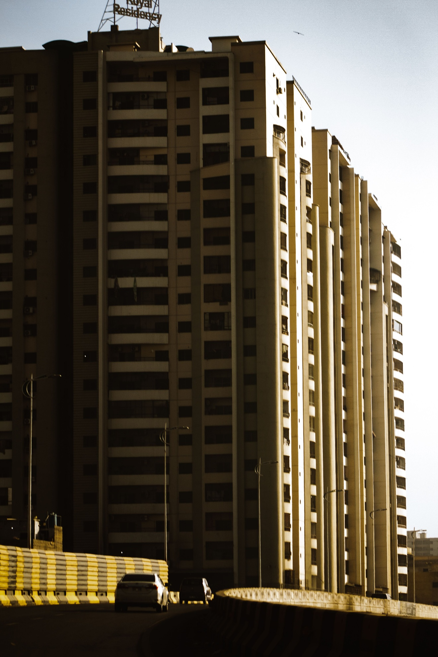

--------------------------------------------------------------------------------
Property 6 — Gulberg Corner Residency
--------------------------------------------------------------------------------

Title: Gulberg Corner Residency — Mid-Rise Corner Apartment
Type: Apartment (Mid-Rise)
Status: For Rent
City: Lahore
Location: Gulberg III, Lahore
Monthly Rent: PKR 95,000 / Month
Security Deposit: 2 Months Advance
Size: 1,100 Sq. Ft.
Floor: 5th Floor (Corner Unit)
Bedrooms: 3
Bathrooms: 2
Agent: Zain Mirza

Short Description:
A spacious corner-unit apartment for rent in Gulberg III Lahore with wraparound glazed balconies, excellent natural light, and a prime location surrounded by Lahore's best dining and business hubs.

Full Description:
Gulberg Corner Residency occupies a premium corner position in a well-known mid-rise residential block in Gulberg III — one of Lahore's most commercially vibrant and residentially sought-after localities. The unit's corner position on the 5th floor gives it a wraparound configuration with large glazed balcony panels on two sides, flooding the interior with daylight and offering pleasant views over the Gulberg tree line.

The 1,100 Sq. Ft. apartment features a central lounge, a separate dining area, 3 bedrooms (including a master with an attached bath), and 2 bathrooms in total. The layout is practical and efficient, equipped with split-unit air conditioning, tiled corridors, and easy elevator access within the 7-storey structure. Gulberg III puts tenants within a 10-minute drive of Liberty Market and M.M. Alam Road, making it an excellent base for corporate professionals who want executive living close to their workplace.

Features & Amenities:
- Corner Unit with Wraparound Glazed Balconies
- 3 Bedrooms, 2 Bathrooms
- Excellent Natural Light on Two Sides
- Elevator-Served Building (7 Storeys)
- Split-Unit Air Conditioning Installed
- Tiled Corridors & Secure Common Areas
- 24/7 Watchman Security
- Covered Parking for 1 Vehicle
- Close to M.M. Alam Road & Liberty Market

GPS Coordinates: 31.5105, 74.3287
Photo Reference: Property 6(Rent).jpg

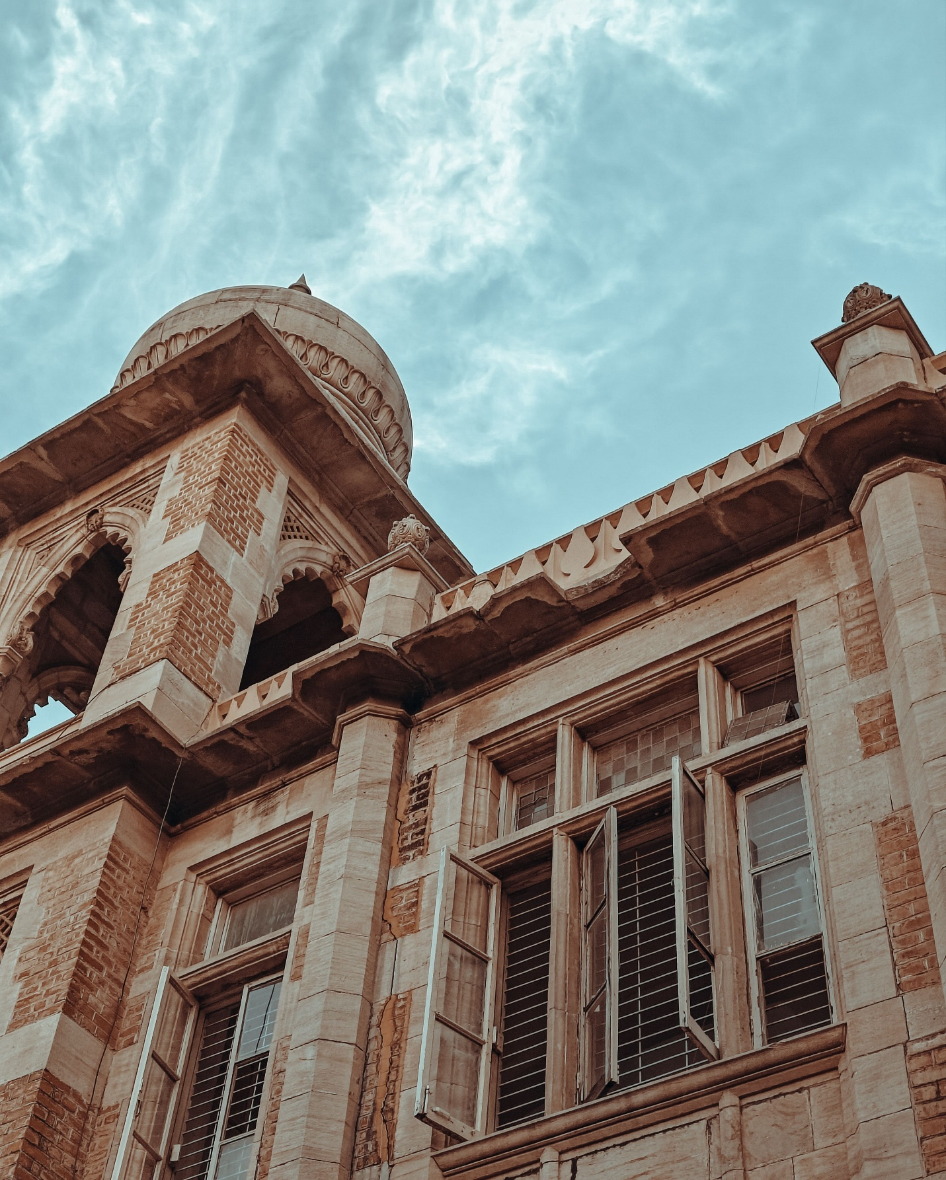

--------------------------------------------------------------------------------
Property 7 — The Pearl Towers Islamabad
--------------------------------------------------------------------------------

Title: The Pearl Towers Islamabad — Ultra-Premium High-Rise Apartment
Type: Apartment (Luxury High-Rise)
Status: For Rent
City: Islamabad
Location: Bahria Town Phase 7, Islamabad
Monthly Rent: PKR 220,000 / Month
Security Deposit: 3 Months Advance
Size: 2,200 Sq. Ft.
Floor: 18th Floor
Bedrooms: 4
Bathrooms: 3
Agent: Zain Mirza

Short Description:
A flagship luxury rental apartment on the 18th floor of one of Islamabad's tallest developments — offering spectacular Margalla Hills views, 4 bedrooms, and world-class amenities in Bahria Town Phase 7.

Full Description:
The Pearl Towers is a landmark development in Islamabad's premium real estate landscape, rising nearly 25 storeys above the Bahria Town Phase 7 skyline. Its beige stone-clad facade with classical detailing and crown cornices gives it a distinguished presence that sets it apart from typical high-rises. Mature pine trees frame the base, softening the building's scale and adding to its exclusivity.

This 2,200 Sq. Ft. rental apartment on the 18th floor represents the top tier of Islamabad residential living. The unit features 4 generously sized bedrooms, 3 full bathrooms (master en-suite with premium imported fixtures), a large formal drawing room, a separate family lounge, and a fully equipped kitchen with an attached breakfast area. Floor-to-ceiling windows throughout frame sweeping views of the Margalla Hills to the north and the Islamabad grid below. Tenants enjoy a full suite of luxury amenities including a fitness center, swimming pool, concierge services, and high-speed elevators.

Features & Amenities:
- 4 Bedrooms, 3 Bathrooms (Master En-Suite)
- 18th Floor with Margalla Hills View
- Floor-to-Ceiling Windows Throughout
- Formal Drawing + Family Lounge Configuration
- Fully Equipped Premium Kitchen
- Access to Building Fitness Centre & Swimming Pool
- High-Speed Elevators (3 Lifts)
- 24/7 Concierge & Manned Security
- 2 Covered Parking Spaces
- Backup Generator (Full Apartment Coverage)

GPS Coordinates: 33.5651, 73.1021
Photo Reference: Property 7(Rent).jpg

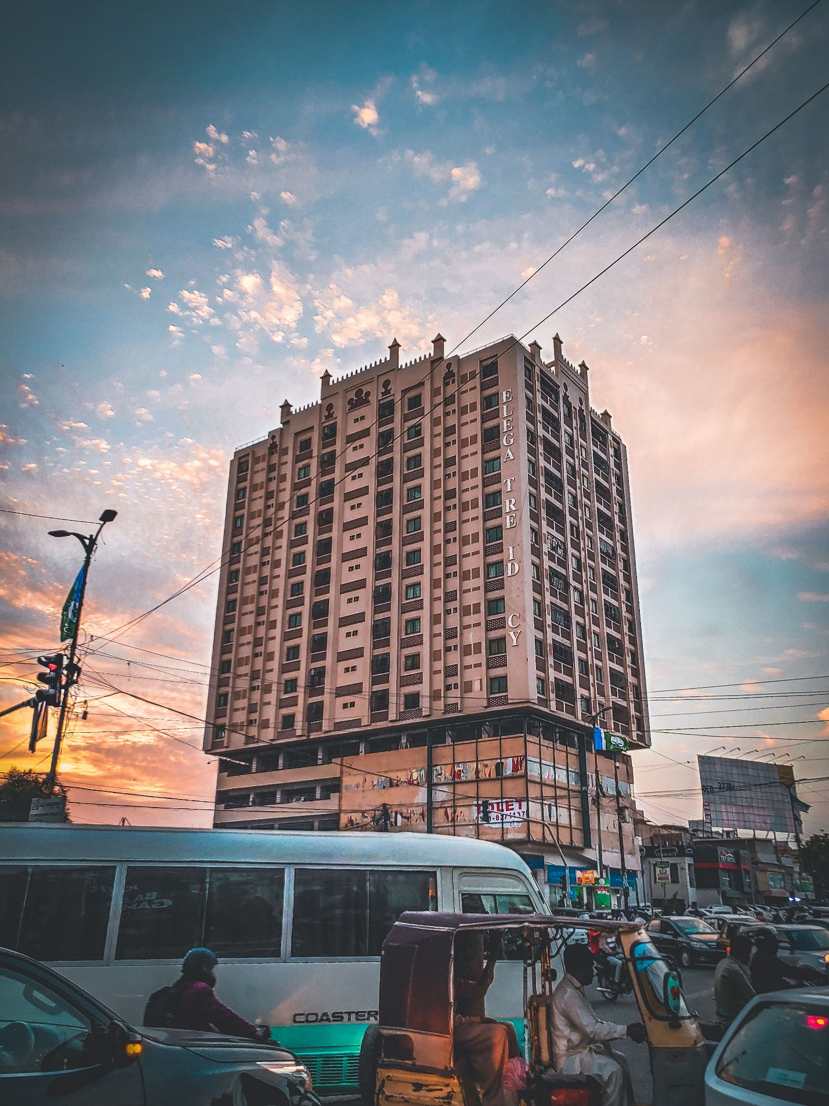

--------------------------------------------------------------------------------
Property 8 — Rawalpindi Green Enclave Apartments
--------------------------------------------------------------------------------

Title: Rawalpindi Green Enclave — Gated Community Apartment Complex
Type: Apartment (Gated Community / Society)
Status: For Rent
City: Rawalpindi
Location: Chaklala Scheme 3, Rawalpindi
Monthly Rent: PKR 38,000 / Month
Security Deposit: 2 Months Advance
Size: 750 Sq. Ft.
Floor: 3rd Floor (Block B)
Bedrooms: 2
Bathrooms: 2
Agent: Zain Mirza

Short Description:
An affordable, family-friendly rental apartment in Chaklala Scheme 3, Rawalpindi — surrounded by manicured green parks, tree-lined pathways, and all basic amenities within short walking distance.

Full Description:
Rawalpindi Green Enclave is a well-established gated residential community in Chaklala Scheme 3 — one of Rawalpindi's most organised and family-friendly localities. The development consists of multiple 6-storey residential blocks set within expansive open green spaces, paved walking paths, and internal community gardens. The layout immediately communicates a sense of space, safety, and a true neighborhood community living environment.

This particular unit is a 750 Sq. Ft., 2-bedroom, 2-bathroom apartment on the 3rd floor of Block B. The layout is highly efficient: a central lounge-dining combined area flows seamlessly into the kitchen, while the two bedrooms are positioned at opposite ends to maximize privacy. The apartment is in fantastic original condition and ready for immediate move-in. The gated community includes internal parks, a mosque, a basic gymnasium, and 24/7 perimeter security, making it ideal for young couples, government employees, and small families.

Features & Amenities:
- 2 Bedrooms, 2 Bathrooms
- Part of a Secure, Large Gated Community Complex
- Manicured Internal Green Parks & Tree-Lined Pathways
- Community Mosque Inside the Complex
- Basic Gymnasium & Community Centre Access
- 24/7 Perimeter Security & Access Management
- Dedicated Parking Area within Complex
- Close to Chaklala Scheme 3 Market & Key Administrative Offices
- 20 Minutes from New Islamabad Airport

GPS Coordinates: 33.6007, 73.1213
Photo Reference: Property 8(Rent).jpg

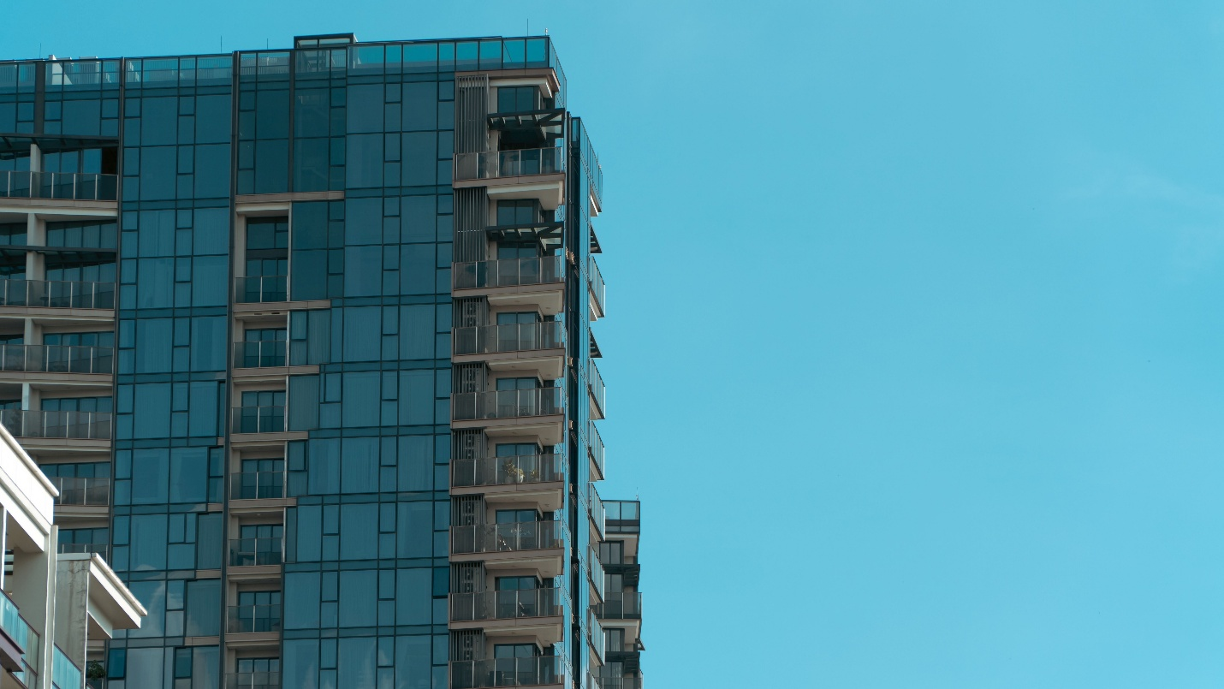
================================================================================
Property Rental Summary Table
================================================================================

# | Title | City | Type | Monthly Rent | Beds | Size | Photo Reference
--|----------------------------------|------------|---------------|-----------------|------|----------------|---------------------
1 | Horizon Crest Tower | Karachi | Apartment | PKR 135,000 | 3 | 1,450 Sq. Ft. | Property 1(Rent).jpg
2 | Al-Faisal Classic Residency | Karachi | Apartment | PKR 65,000 | 2 | 900 Sq. Ft. | Property 2(Rent).jpg
3 | Green Canopy Cottage | Islamabad | House/Cottage | PKR 110,000 | 2 | 5 Marla | property 3(rent).jpg
4 | Noor-ul-Hayat Grand Plaza | Islamabad | Commercial | PKR 1,400,000 | N/A | 8,000 Sq. Ft. | Property 4(rent).jpg
5 | Bosphorus View Mansion | Lahore | Villa | PKR 450,000 | 6 | 2 Kanal | Property 5(Rent).jpg
6 | Gulberg Corner Residency | Lahore | Apartment | PKR 95,000 | 3 | 1,100 Sq. Ft. | Property 6(Rent).jpg
7 | The Pearl Towers Islamabad | Islamabad | Luxury Apt | PKR 220,000 | 4 | 2,200 Sq. Ft. | Property 7(Rent).jpg
8 | Rawalpindi Green Enclave | Rawalpindi | Gated Apt | PKR 38,000 | 2 | 750 Sq. Ft. | Property 8(Rent).jpg

================================================================================
Note: All data is presented for demo/portfolio purposes. Rental pricing estimates are structured to reflect current 2026 Pakistan market benchmarks for executive leasing options.
================================================================================

